
Leveraging Azure Site Recovery via Azure Migrate Guide (Physical Replication)

Cognizant Microsoft Business Group
20 North Wacker Drive #530
Chicago, IL 60606

Notice of Confidentiality ©2021 Cognizant Microsoft Business Group All rights reserved.

IS SUBJECT TO THE TERMS OF THE COGNIZANT MICROSOFT BUSINESS GROUP NON-DISCLOSURE AGREEMENT. NEITHER THIS DOCUMENT NOR ITS CONTENTS MAY BE REVEALED OR DISCLOSED TO UNAUTHORIZED PERSONS OR SENT OUTSIDE THE AFOREMENTIONED COMPANY WITHOUT PRIOR PERMISSION FROM COGNIZANT MICROSOFT BUSINESS GROUP
Table of Contents
Summary 3
Azure Migrate Deployment 3
Azure Migrate (Physical Replication) Considerations 3
Azure Migrate (Physical Replication) requirements 3
Configuring Azure Migrate Recovery Services Vault & Begin replication 4

Summary
This is a general guide to leveraging the backend Recovery Services Vault that is created for any Azure Migrate Project. The guide will cover the necessary steps to follow allowing you to leverage the ASR backend on AzureMigrate to push the Mobility Agent to Windows systems or supported Linux Operating Systems. (Special Linux restrictions are in the links below) This will come in handy as Azure Migrate does not natively support pushing the Mobility Agent for Migrate as Physical projects.

Azure Migrate Deployment
Before you start, it is a good idea to review MBG's Azure Migrate Guide and the Microsoft ASR Setup Guide to get a clear understanding of the architecture and what needs to be deployed to support the migration.

Useful reference links:
https://docs.microsoft.com/en-us/azure/migrate/tutorial-migrate-physical-virtual-machines
Support matrix for VMware/physical disaster recovery in Azure Site Recovery - Azure Site Recovery
Discover, assess, and migrate Amazon Web Services (AWS) EC2 VMs to Azure - Azure Migrate

Azure Migrate (Physical Replication) Considerations

- Azure Migrate: Server Assessment (Discovery) and Server Migration(Configuration) need to be two separate VM's
  - Reference "Prepare a machine for the replication appliance" section ( https://docs.microsoft.com/en-us/azure/migrate/tutorial-migrate-physical-virtual-machines )

- The Discovery server is a 50MB PowerShell install that does a stripped-down config server setup.
  - This will generate assessments, but they cannot be used in automatic sizing or disk type settings.
  - Azure Migrate will default to automatic sizing based off on-prem but not off assessment.

- Physical replication will require manual Mobility service install for Linux machines without Password Authentication enabled.
  - Install instructions (Migrate machines as physical server to Azure with Azure Migrate. - Azure Migrate | Microsoft Docs)

Azure Migrate (Physical Replication) requirements

- Azure Migrate Project
  - Configuration server with proper root/administrator credentials for target machines connected to Azure Migrate

Configuring Azure Migrate Recovery Services Vault & Begin replication
- Navigate to the Recovery Services Vaults via the Azure Portal.
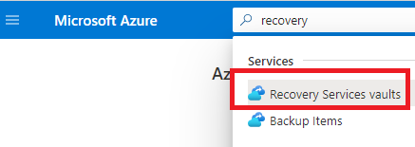
- Find the Recovery Services Vault associated with your Azure Migrate project.
- Select Site Recovery Infrastructure
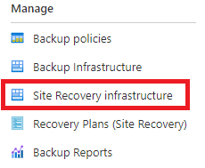
- Select Replication Policies
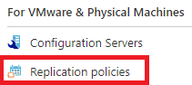
- Create a new replication policy. (This will automatically create a failback policy as well)


- Associate your two newly created policies to your Configuration Server.
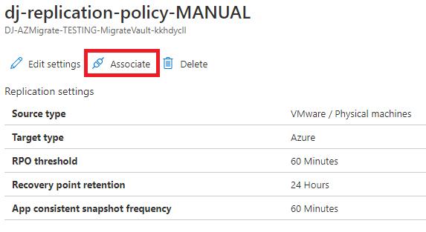
- Navigate back to your Recovery Services Vault and select Replicated Items.
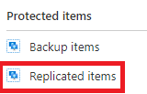
- Select Replicate -> VMWare and physical machines to Azure
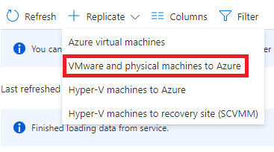
- Follow through the steps as you would with ASR physical migration.
- Once the machine begins replicating you can manage it via the Recovery Services Vault or via the Azure Migrate project for testing and failover.

